**SCOPE OF WORK**

Contents

2 MOBILE APPLICATION 2

2.1 Features 3

2.1.1 Asset installation 3

2.1.2 Post installtion testing 3

2.1.3 Program Scheduling 4

2.1.4 Preventive Maintenance Scheduling 4

2.1.5 Live Monitoring 4

2.1.6 Asset Management integration 5

2.1.7 Asset Movement 5

2.1.8 Maintenance/Ticketing 6

2.1.9 Scanning of Barcodes/QR Codes 6

2.1.10 User-defined role 6

2.1.11 Historical data and archiving 6

2.1.12 document Upload 6

2.1.13 Notifications Center 6

2.1.14 Linking Assets 6

2.1.15 KPI and statistics and dashboard 7

2.1.16 GIS based tracking 8

3 Integration with MMIS and AMS 9

# MOBILE APPLICATION

To provide Mobile Application and Back Office Supervisor/Administration Software Solution to facilitate the collection, consolidation, and analysis of data from program scheduling, task assignments, installation, asset condition inspections and real-time monitoring of assets with health dashboards. Monitor assets that are spread across the region with mobile app that will give mobile workforce access to installation maintenance, inspection check sheets and work history. The dashboard tracks and trends installation activities, assets’ details, program etc. driving proactive inspections and enabling active monitoring of the project implementation.

Application will provide dashboard and Reports of assets with robust capabilities that enables the following:

* Analyze data
* Analyze installations
* Analyze Project Progress
* Monitor, and visualize asset health
* Navigate to assets by spatial data
* Review Key Performance indicators
* Review status
* Track failures
* Assign crew to various tasks
* Manage installation and progress
* Manage asset details and inventory
* Integration with inventory system.
* Create maintenance log for every asset
* Track crew daily progress

System provides full visibility and control of assets from a centralized web back office application, allowing to securely monitor the asset installation, maintenance, events, inspections, set schedules, maintenance and monitoring of the implementation and O&M staff KPIs.

The application is designed to have data encryption and two-factor authentication to ensure that the software meets the most stringent security standards. Easy to use application provide a complete view of the connected/related assets, enabling to manage workflows of installation activities and to deploy installation crews as needed.

The application is built with complete flexibility with REST API based easy integration with other intelligent platforms and IoT devices, ensuring keep pace with smart city trends – now and in the future.

The mobile application will integrate with the following legacy systems:

* Asset Management System
* Maintenance Management System

## Features

The system will provide comprehensive management of the complete lifecycle from planning, installation to maintenance of the assets.

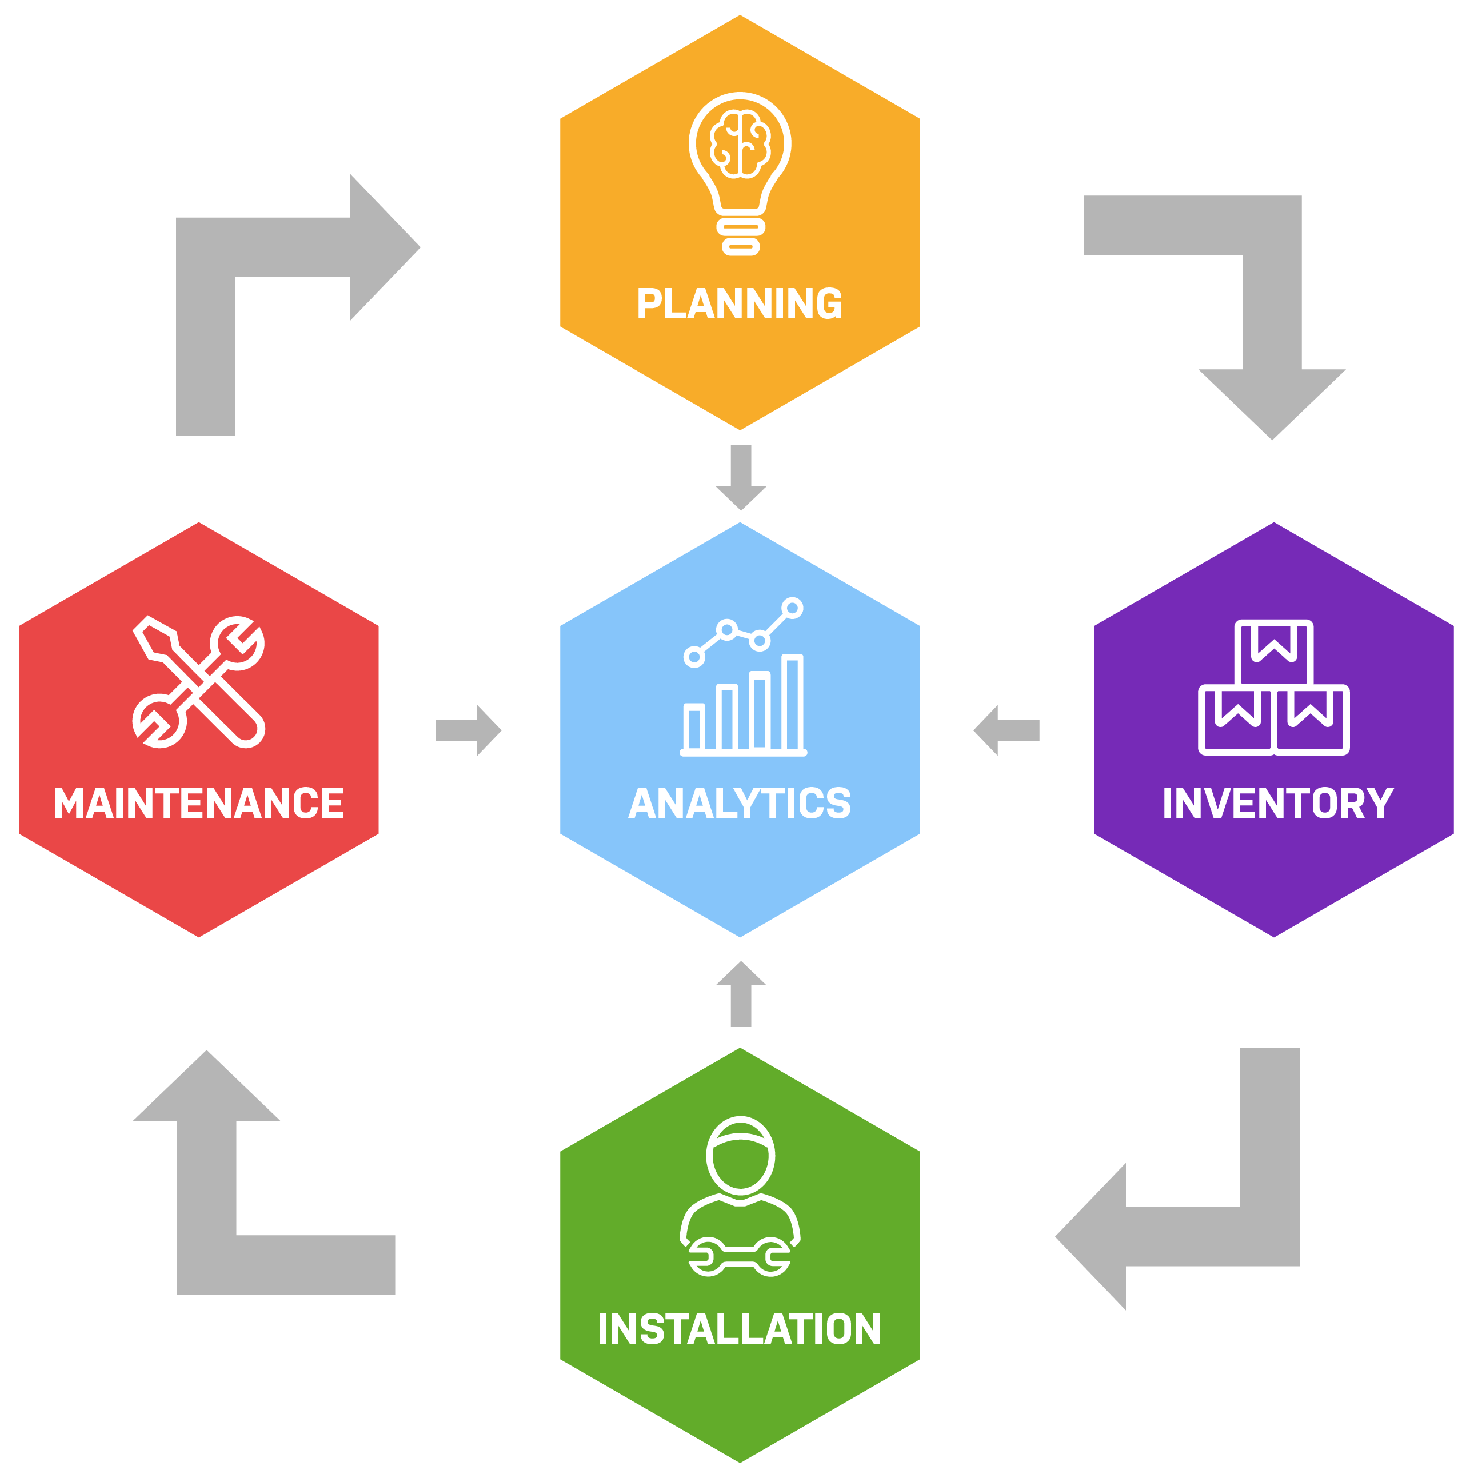

*System Workflow*

### Asset installation

The mobile application provides access to context-rich visualizations and actionable insights to enable simple and timely execution of end-to-end asset installation and post installation processes. Once the user logs in, application provide the list of assigned tasks/zones for crew to initiate the installation process. User can filter the tasks based on date/zones/main streets or priority. As soon as the installation is be complete, user will upload the installation evidence for each asset to system using the mobile app. The evidence can be photos, videos or other documents.

The mobile application provides various functions to fully update the back office with installation progress and schedule.

### Post installtion testing

The application can be used for both periodic inspection or testing the assets after installation and uploading the details with evidence. Using the mobile application users will complete inspections without missing out on important details.

Mobile App allow to add rich data such as photos, annotations, geographic coordinate, attribute, Signatures, Audio/Video. Apps allow to capture photos using device’s camera, quickly snap and attach images to an inspection. GPS functionality makes it easy to identify exact locations during an inspection. User can drop a pin to generate an address with coordinates.

### Program Scheduling

System allow authorized users to plan and feed in the complete program of the project into the system up to the level of no. of asset installation, staff required, and schedule of the installation/replacement of equipment. System will track the progress of crews and project overall against this program and notify and suggest the corrective actions when required. The system allows to drilldown details to the zones, sectors and streets as well using the application’s GIS based features.

### Preventive Maintenance Scheduling

Preventive maintenance is regular, planned maintenance that is scheduled according to usage or time-based triggers. The purpose of maintenance is to lessen the likelihood of equipment breakdowns.

Mobile app has the preventive maintenance module were authorized users can plan maintenance activities and manage schedules of assets preventive maintenance and create checklists in schedules to maintain periodic tasks.

Application also allows to gather data surrounding preventive maintenance activities to report on or optimize those activities and set maintenance KPIs to work towards.

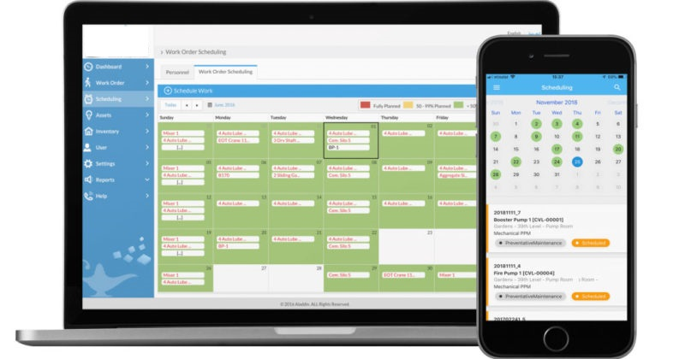

*Fig. 2: Design Idea: Scheduling from Backoffice and Crew view their assignments*

### Live Monitoring

Live monitoring features proactively monitor the installation of inventory, health of assets and performance and activities of the crew and alerts stakeholders to take corrective actions in real-time.

System provides with insight into all active tasks of each crew member. User can also evaluate his own performance based on assigned vs actual performed activities.

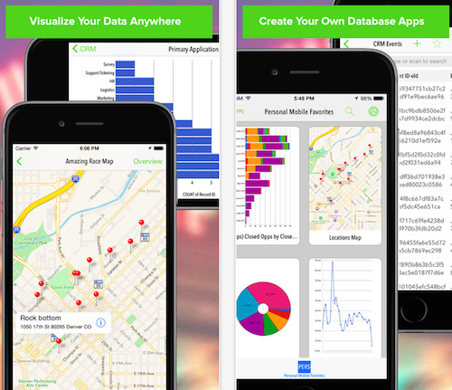Real-time monitoring feature lets crew upload data directly from mobile application, with failure reports, meter readings and installed assets evidence as photos/videos, and documents.

Using real-time data from the program schedule, system automatically informs personnel when it is time for installation in specific area, inspection and preventive maintenance.

The application also provides a basis for continual improvement. For example, allowing users to compare the performance of several assets of the same type and identifying the performance gaps and plan accordingly.

In addition, the system also supports improved administration by linking all information relating to the asset in one place which allow user to pull information from asset inventory, asset management and maintenance of these assets.

### Asset Management integration

Using Integration with Asset Management system (AMS), the Basic Asset Management related functions can be easily implemented and data can be retrieved through the mobile application and the user can track all the details including inventory data, spare parts, location of all assets on the App. From the asset’s procurement details to their discard, all can be monitored on the mobile application.

The end-user can access all the information of the related asset. This information can include asset details, pending activities, scheduled installation, pending tickets, and pending checks/inspections of asset.

Once the assets are installed on designated site with evidence, the real time data can be pushed through REST API interface to back-office Asset Management System (AMS), to ensure the easy access and business continuity for the project operation team.

### Asset Movement

Assets can be transferred to another location/site or to the person employed in another department. Assets can even transfer back to the inventory.

User can also capture images, videos or files related to the assets while transferring them.

Through this transfer of assets, check-in and check-out can also be tracked easily and precisely.

### Maintenance/Ticketing

Authorized Users can raise maintenance tickets or queries through their mobile app. These raised tickets will be notified through an email, SMS, and push-notification.

User can check all tickets by their status like open, assigned, pending, or closed from a single dashboard.

Whenever the ticket will be closed it will be notified through email, with the details of rectification.

System can be customized where either supervisor can assign technician to the ticket or maintenance request can come through integration with Maintenance System and the system should update Maintenance System when the ticket is closed.

### Scanning of Barcodes/QR Codes

Scanning of barcodes and QR codes of assets is possible through the smartphone using the built-in camera. Details included in the barcode and QR code will be scanned as applicable and stored in the database. The data related to asset may include type, specification, production, location of installation, time etc. for all the asset data will be retrieved through integration with inventory system or asset management system.

### User-defined role

The system allows to specify user roles for each user of the mobile application. Each role can be linked to specific feature/module of the application depending on the function of the specific user and authority level granted.

### Historical data and archiving

Application allow the user to track and search archived records and access to installation history, asset, maintenance, and repairs provided in the mobile app. This is to get the user to keep track of the events and changes made in the past.

### document Upload

Mobile application allows upload various document including material certificates, NOCs, Images and Videos of the installations and maintenance work as an evident and link them to assigned activities in the program, it can be task or asset related.

### Notifications Center

Staying up to date with the help of notifications are the primary features of any mobile app. The Mobile application is equipped with comprehensive notification center providing various types of notifications as push notification. Users will be notified with various data feeds like new task assignments or coming-up scheduled maintenance, assignments, the status of generated tickets, etc.

### Linking Assets

Application allow user to link the various assets installed on specific area/task. Users scan the QR/BR of each asset and link them to specific asset/region/type.

### KPI and statistics and dashboard

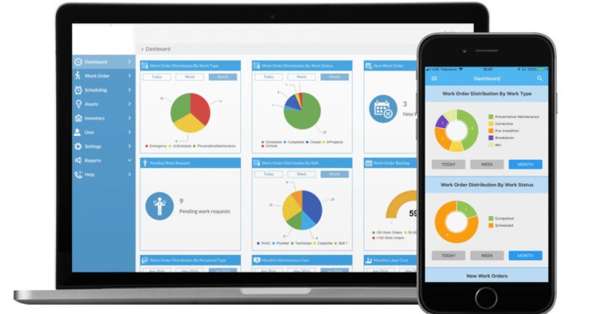

KPI is a measurable value that indicates the performance of the business objectives. The Mobile Application analytics module gives the data needed to drill down into the details and measure the installation and performance of assets and O&M staff by providing straightforward KPI and performance evaluation.

Application provides real time analytics on a user-friendly interface that is easily accessible and understandable with unique color schemes for its users.

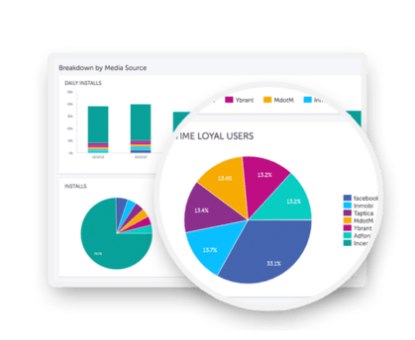

System provides dashboard(s) for supervisors for quick and easy access to monitor program status, installations, progress, failures and exceptions.

Track progress and maintenance crew performance against KPIs; identify trends, implement enhancements and optimize workflows. Realtime dashboards provides the insight and progress based on actual vs planned activities.

Dashboard can be expended to provide:

* Comparing the actual vs planned of project data.
* Easily track progress at the sectors, main streets and highways level, within each zone, and even down to a single sector.
* Compare and filter crew progress
* KPIs and statistics by day, week and months.
* Inventory statistics.

### GIS based tracking

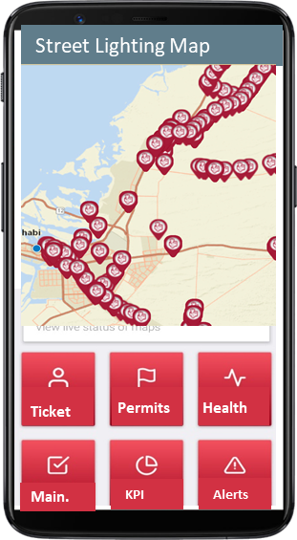

Application provide GIS based tracking of the active crew in shift, required asset installation, inventory and much more. The usage can be very wide: the application can be used simply for navigation purposed (routing and tracking of crew and assets) or for update inventories characterized by a geographic component, for events and incidents reporting. The application can provide map with various layers of data to distinguish the different tasks from highways, main streets to inner streets to sector and zones to make it much simpler and easier for supervisors to assign tasks to crew members and track the progress.

# Integration with MMIS and AMS

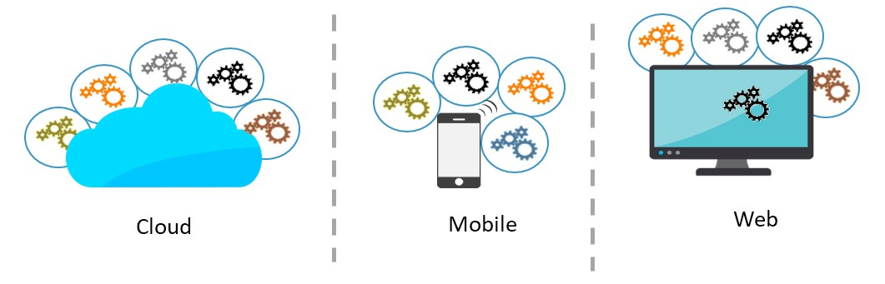

Solution can integrate the existing back office Asset Management System (AMS), Existing Maintenance Management System (MMIS) and any other legacy system already in production using REST APIs.

One of the popular types of API is REST or, as they’re known, RESTful APIs. REST or RESTful APIs were designed to take advantage of existing protocols. While REST - or Representational State Transfer - can be used over nearly any protocol, when used for web APIs it typically takes advantage of HTTP.

That means that there is no need to install additional software or libraries when creating a REST API.

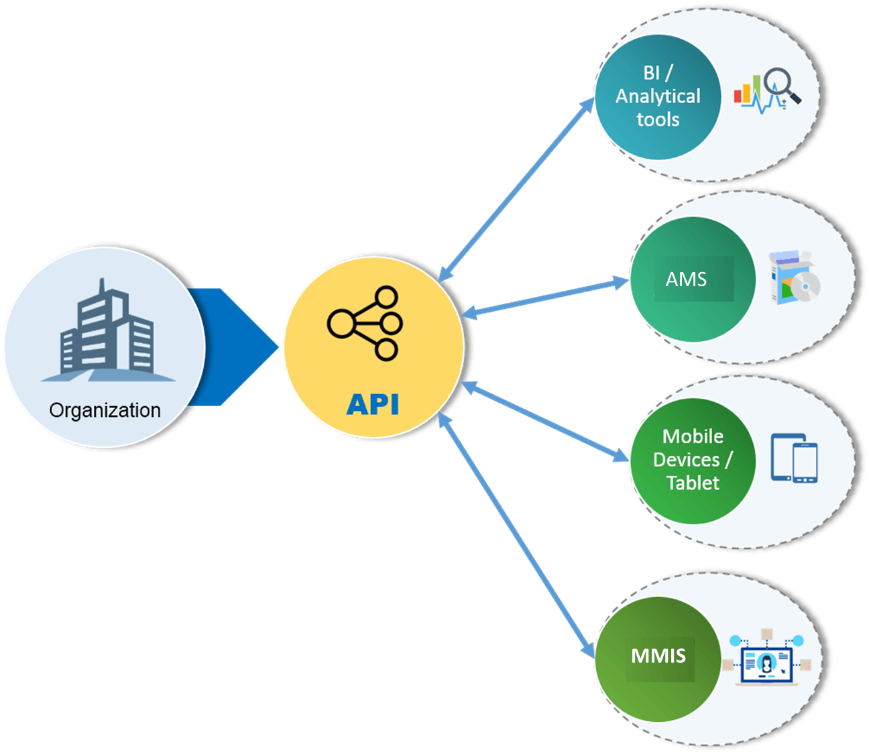

One of the key advantages of REST APIs is that they provide a great deal of flexibility.

Data is not tied to resources or methods, so REST can handle multiple types of calls, return different data formats and even change structurally with the correct implementation of hypermedia.